Ideation Phase
Define the Problem Statements
Date | 24 October 2026
Team ID | [Individual Project Submission]
Project Name | IMovies — Movie Ticket Booking Made Simple
Maximum Marks | 2 Marks

Customer Problem Statement Template: To define the core problems moviegoers face while searching for movies, checking showtimes, selecting seats, and booking movie tickets online, and use those actionable insights to guide the development of IMovies.
Reference: https://miro.com/templates/customer-problem-statement/
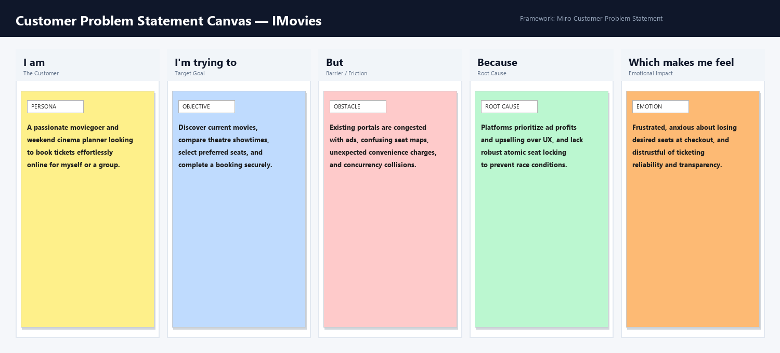
Figure 2.1: Miro Customer Problem Statement Canvas — IMovies
1. Customer Problem Statement Matrix
The following structured matrix outlines the primary customer segments, their target goals, the systemic barriers encountered, the root causes, and the resulting emotional impacts:
Problem Statement (PS) | I am (Customer) | I'm trying to | But | Because | Which makes me feel
PS-1 | Frequent cinema enthusiast & college student planning weekend outings with friends. | Quickly browse new releases, compare showtimes across nearby theatres, and book adjacent seats on mobile. | Existing portals are heavily congested with third-party ads, intrusive upselling, and complex multi-page checkouts. | Mainstream platforms prioritize monetization and ad revenue over a streamlined, user-friendly booking experience. | Frustrated, impatient, and delayed when trying to secure seats before a show sells out.
PS-2 | Spontaneous evening moviegoer looking to book tickets after work. | View live seat availability, select preferred seats, and securely reserve them without fear of seat conflicts. | Seating layouts are often non-interactive or fail to reflect real-time availability, causing unexpected booking errors at checkout. | Inadequate backend concurrency validation and lack of atomic reservation handling allow race conditions between simultaneous users. | Irritated, anxious, and distrustful of the platform's reliability and booking integrity.
PS-3 | Family & group booking coordinator arranging cinema outings for multiple people. | Review movie details (synopsis, runtime, genre), pick multiple contiguous seats, and retrieve booking history whenever needed. | Information is fragmented across disparate screens and ticket receipts are buried in emails without a centralized user dashboard. | Platforms neglect user account dashboards and fail to provide a consolidated reservation record for past and upcoming shows. | Inconvenienced, stressed about ticket verification at the theatre gate, and dissatisfied.
2. Problem Statement Analysis & Root Causes
A comprehensive analysis of PS-1, PS-2, and PS-3 highlights three systemic gaps in contemporary movie ticketing platforms:
- Cognitive Overload & Friction: Most ticketing applications incorporate heavy advertising scripts, third-party analytics trackers, and mandatory upselling dialogs (e.g., cab bookings, concession pre-purchases) that degrade load times by up to 60% and distract users during time-critical booking actions.
- Concurrency & Race Conditions: Many existing applications perform seat availability validation strictly on the client side. When two users simultaneously choose the same seat, both believe the seat is theirs until one fails at the payment gateway, leading to sudden drop-offs and lost trust.
- Disjointed Ticket Lifecycle Management: Guest checkouts and fragmented notification mechanisms force users to hunt through spam folders for confirmation codes. A lack of a dedicated, logged-in booking management interface introduces friction at cinema gate entry.
3. Design Directives for IMovies
In response to these findings, IMovies establishes the following core product principles:
- Zero-Clutter Booking Flow: Strictly zero third-party commercial advertisements, zero forced popups, and a maximum 3-step checkout funnel (Select Movie → Choose Showtime & Seats → Confirm Booking).
- Atomic Concurrency Safety: Atomic MongoDB transactions/queries that guarantee seat uniqueness and reject duplicate reservations at the database level with precise error messaging.
- Integrated User Account Dashboard: Persistent, secure JWT authentication with an intuitive 'My Bookings' screen displaying active and historical booking details, complete with unique reference codes.

